Version:09-02-2017

Author: Alexander Boffin

**Setting Up WebDriver in IntelliJ IDEA**

1)Installing the components of Java

a) Go to <https://www.java.com/nl/>



b) Click on the red button “Free Java download” to download Java. Then agree to the conditions (click “Agree and Start Free Download”).

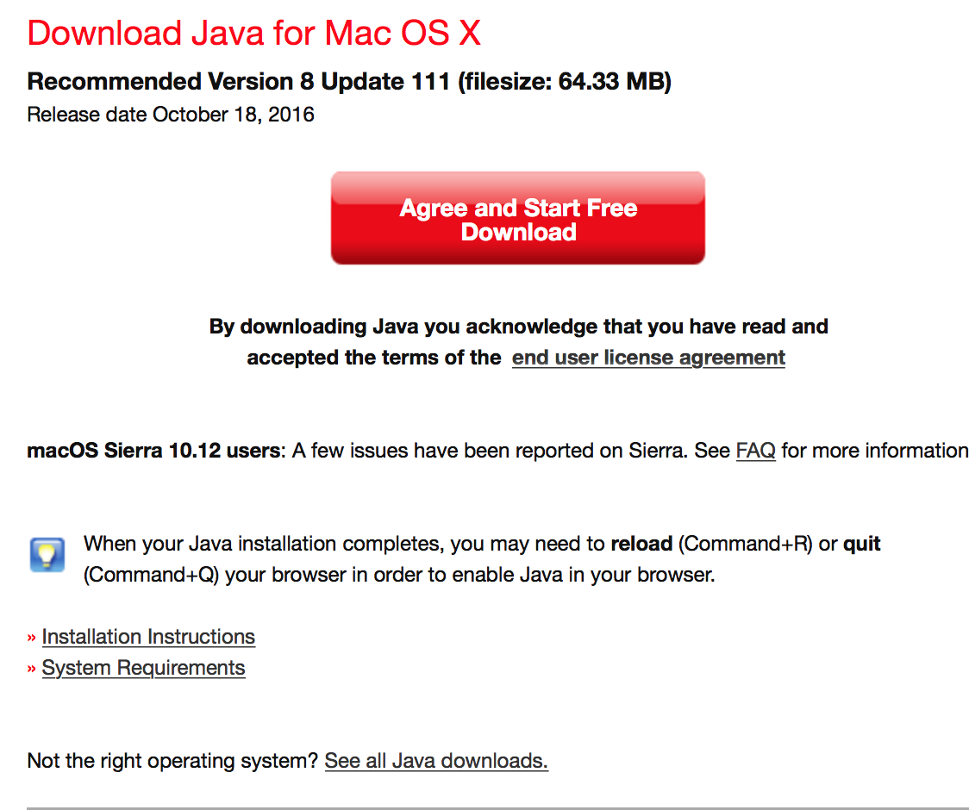

c)Save the file in a folder and open it. Follow the installation instructions that

d)Go to <http://www.oracle.com/technetwork/java/javase/downloads/jdk8-downloads-2133151.html>

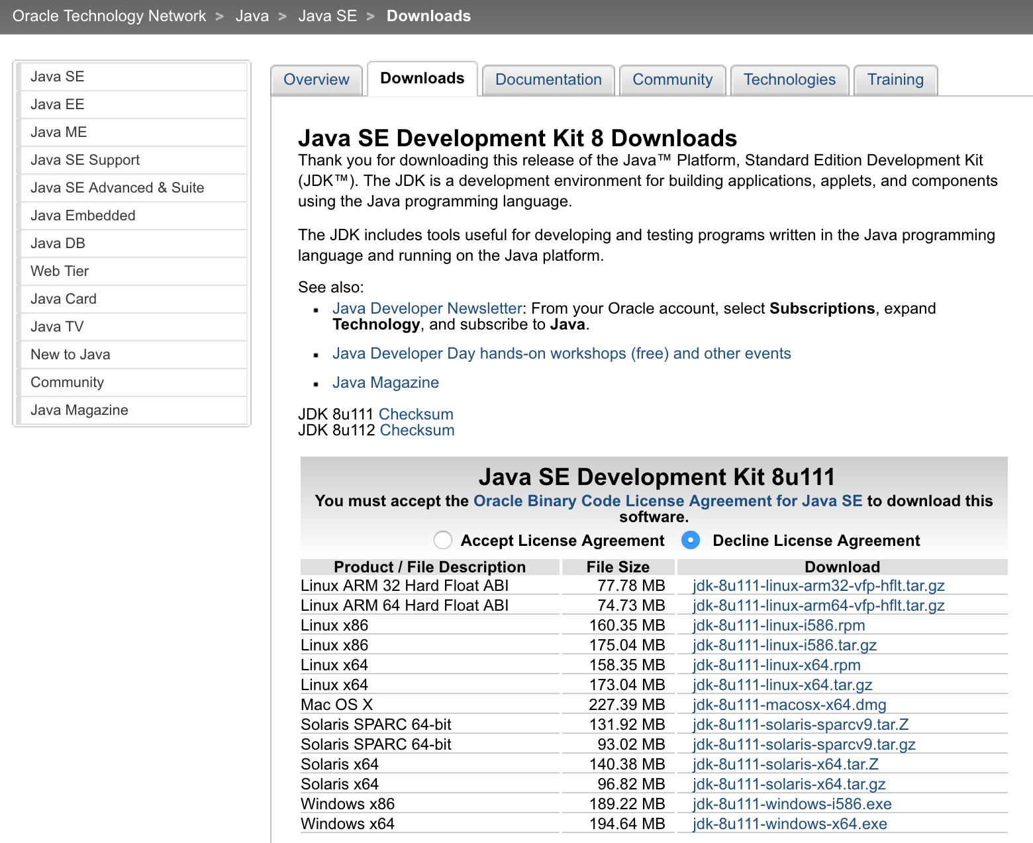

e) Select the last version of JDK for Mac. Download this and execute again the instructions on screen when opening the file.

2)Installing IntelliJ

a) Navigate to <https://www.jetbrains.com/idea/download/>

b) Chose macOS

c)Take the Community download

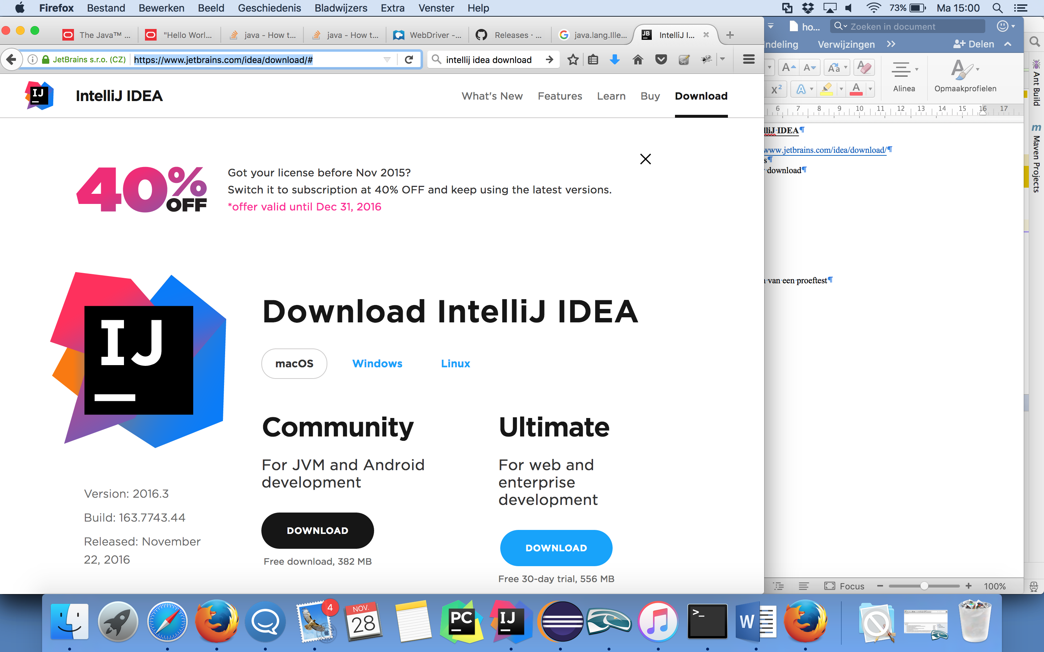

d)Open it after the download and follow the instructions on the screen.

3)Install gekkodriver

a) Navigate to <https://github.com/mozilla/geckodriver/releases>

b) Chose the most recent geckodriver -v….

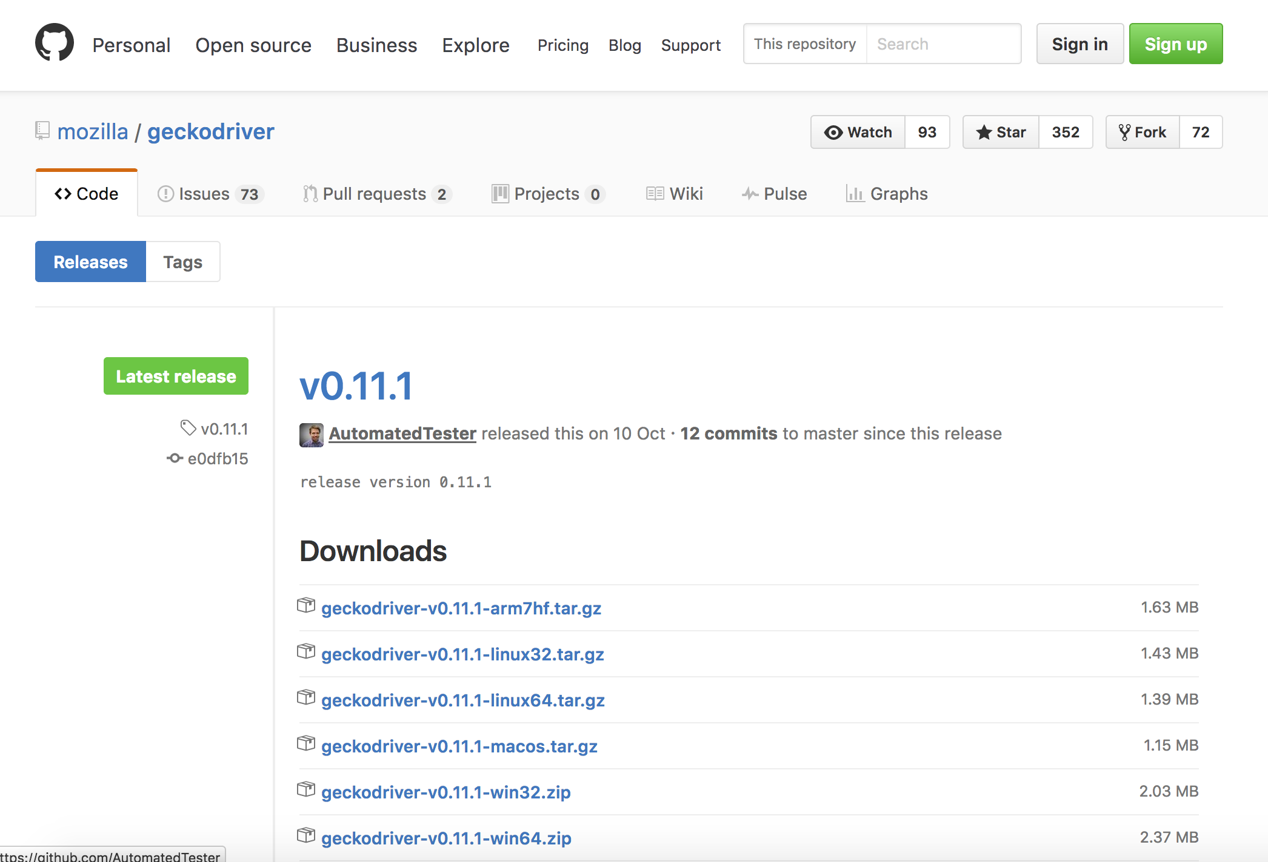

c)Save the file on your computer on a save place (where you can quickly find it).

d)Unzip the file (I used the following program for this: Keka, form <http://www.kekaosx.com/en/>).

4)Create a new project

a) Open IntelliJ

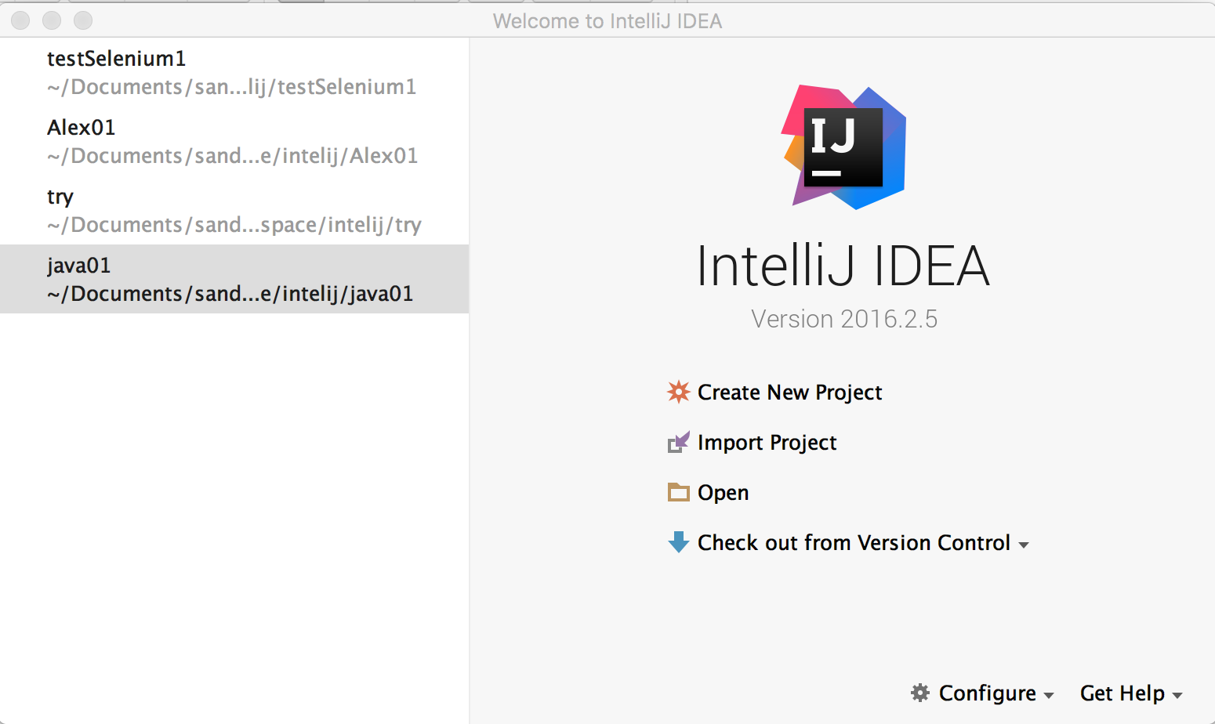

b)Select “Create New Project”

c)Chose the MAVEN option in the left column. Make sure that the latest version of Java is selected at the “Project SDK:” field. (1.8 or higher). Click “Next”.

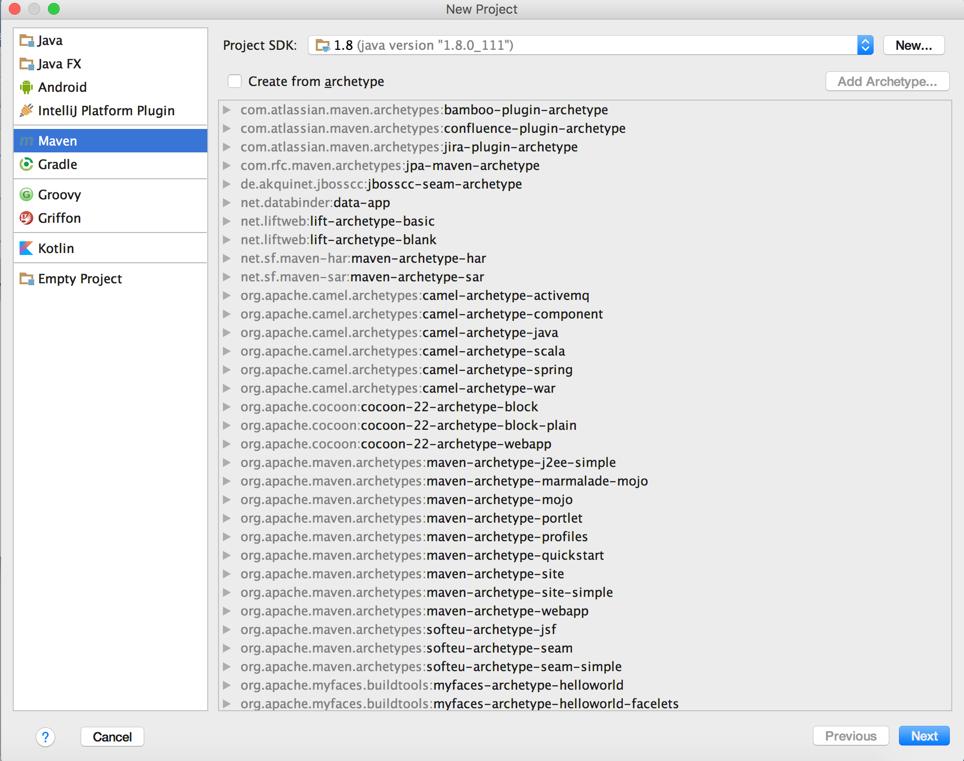

d) Fill in the GroupId and ArtefactId before moving on.

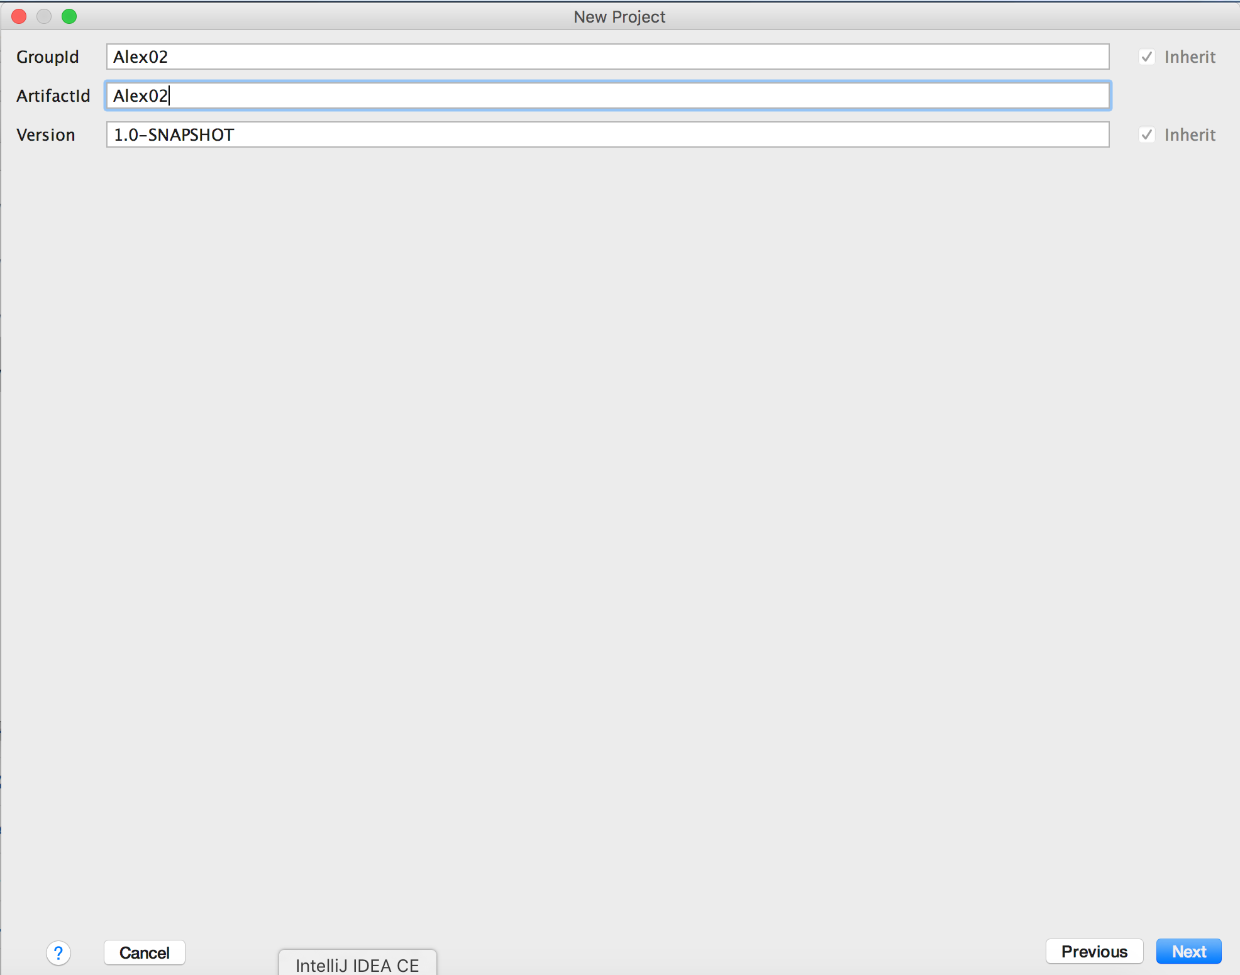

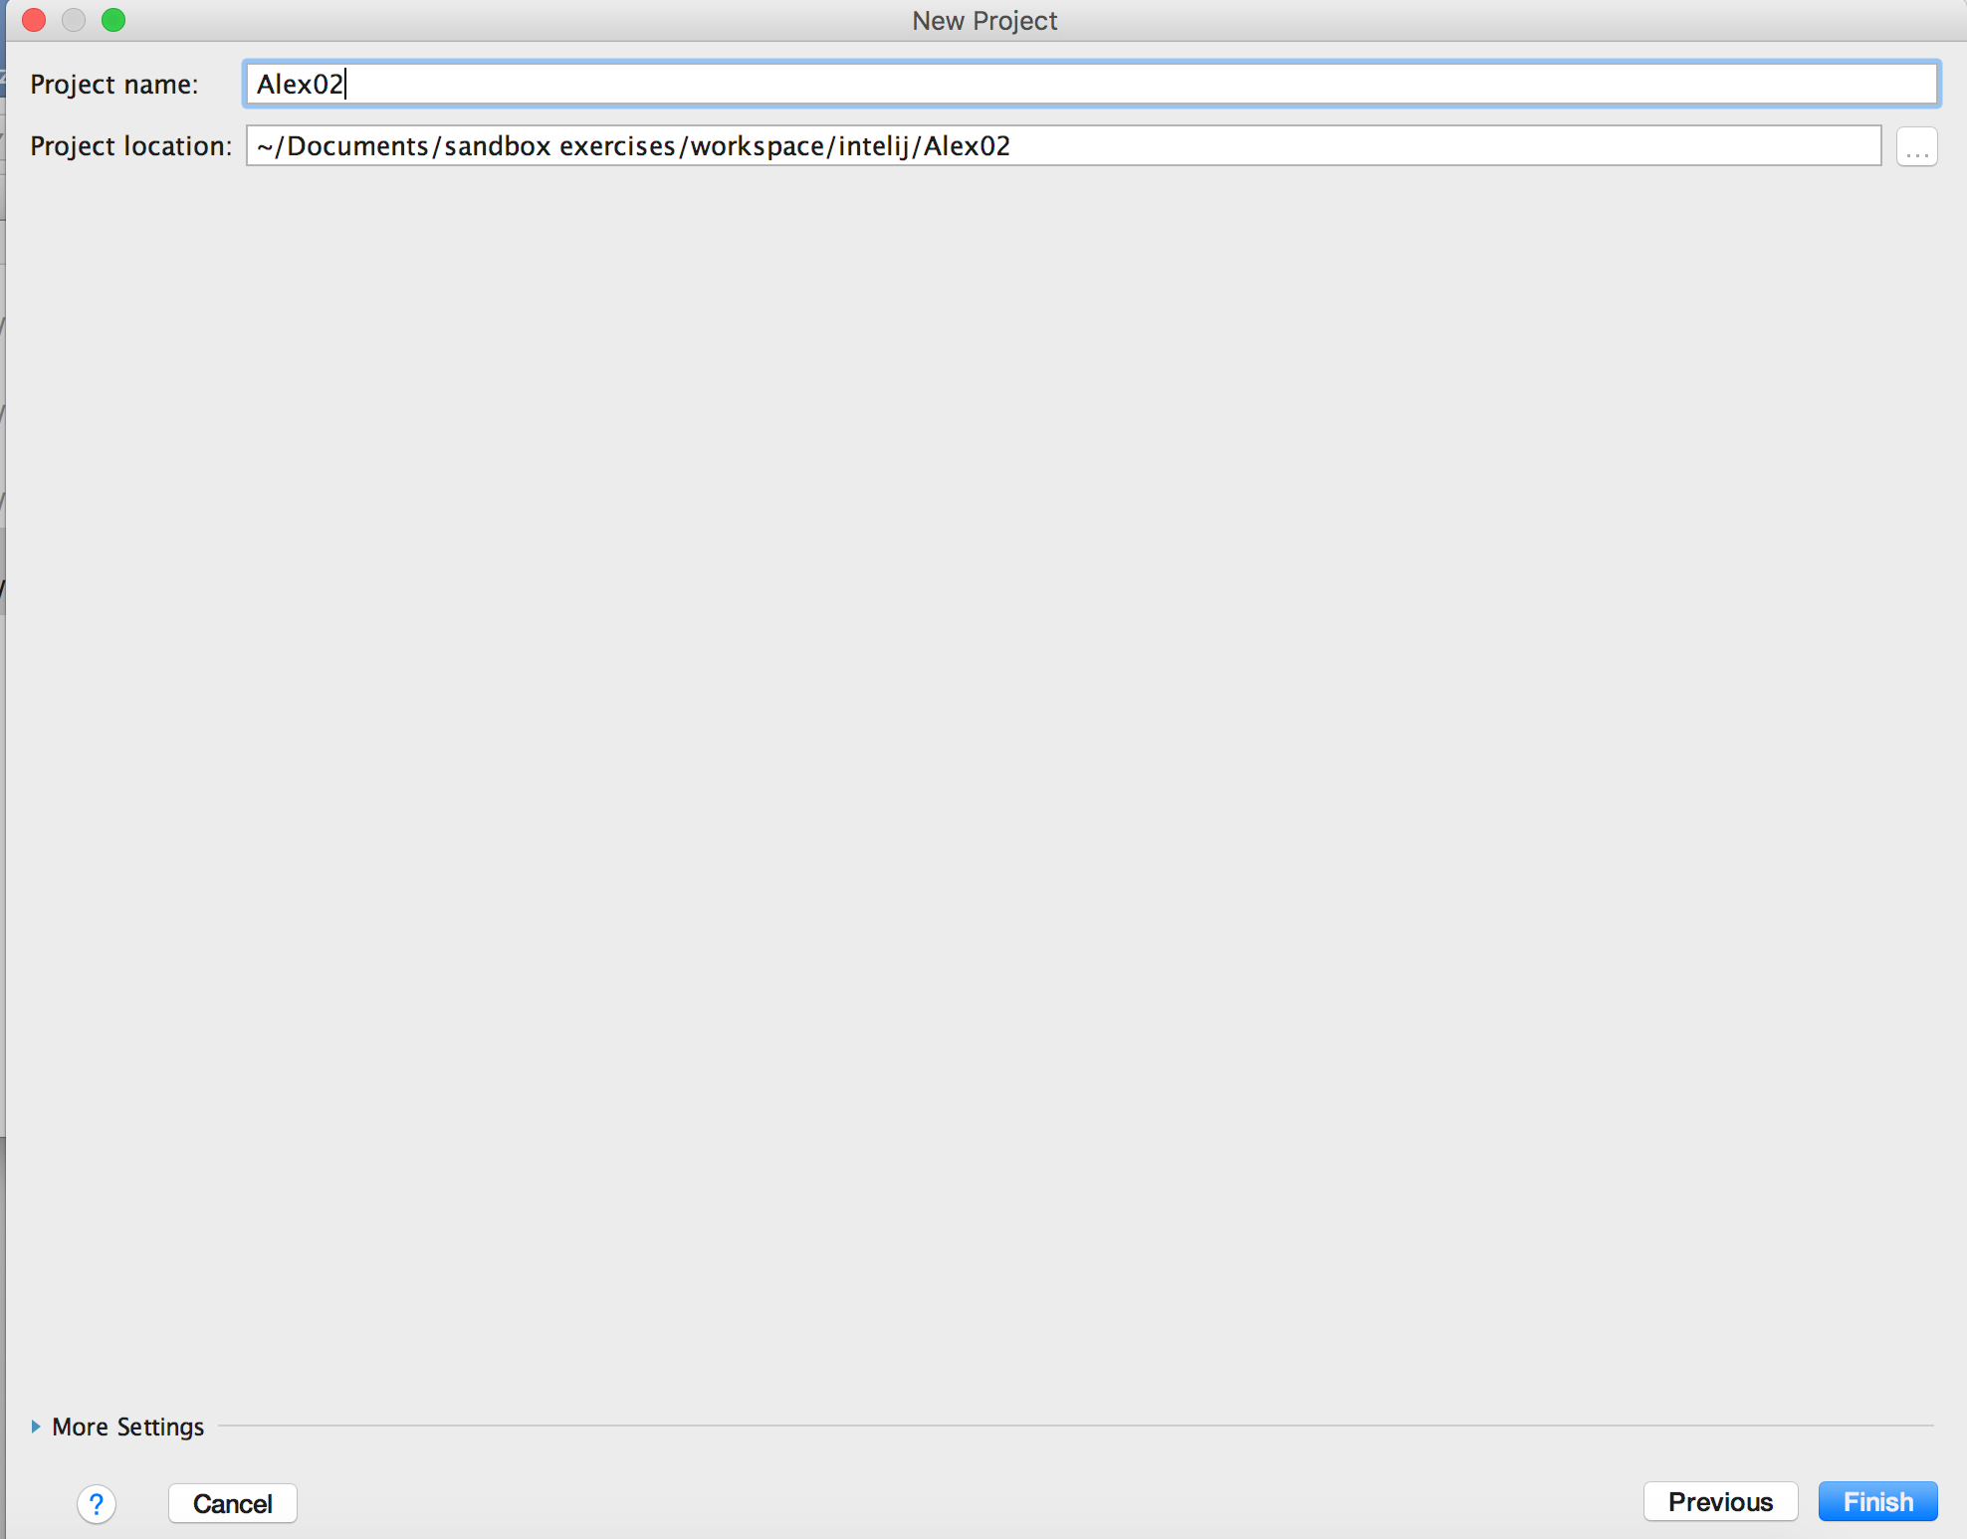

e)Fill in the “Project name” and move on.





5)Add elements to the POM-file

a) Navigate to the POM-file in the left column. A box will appear down right. Select “Enable Auto-Import” here.

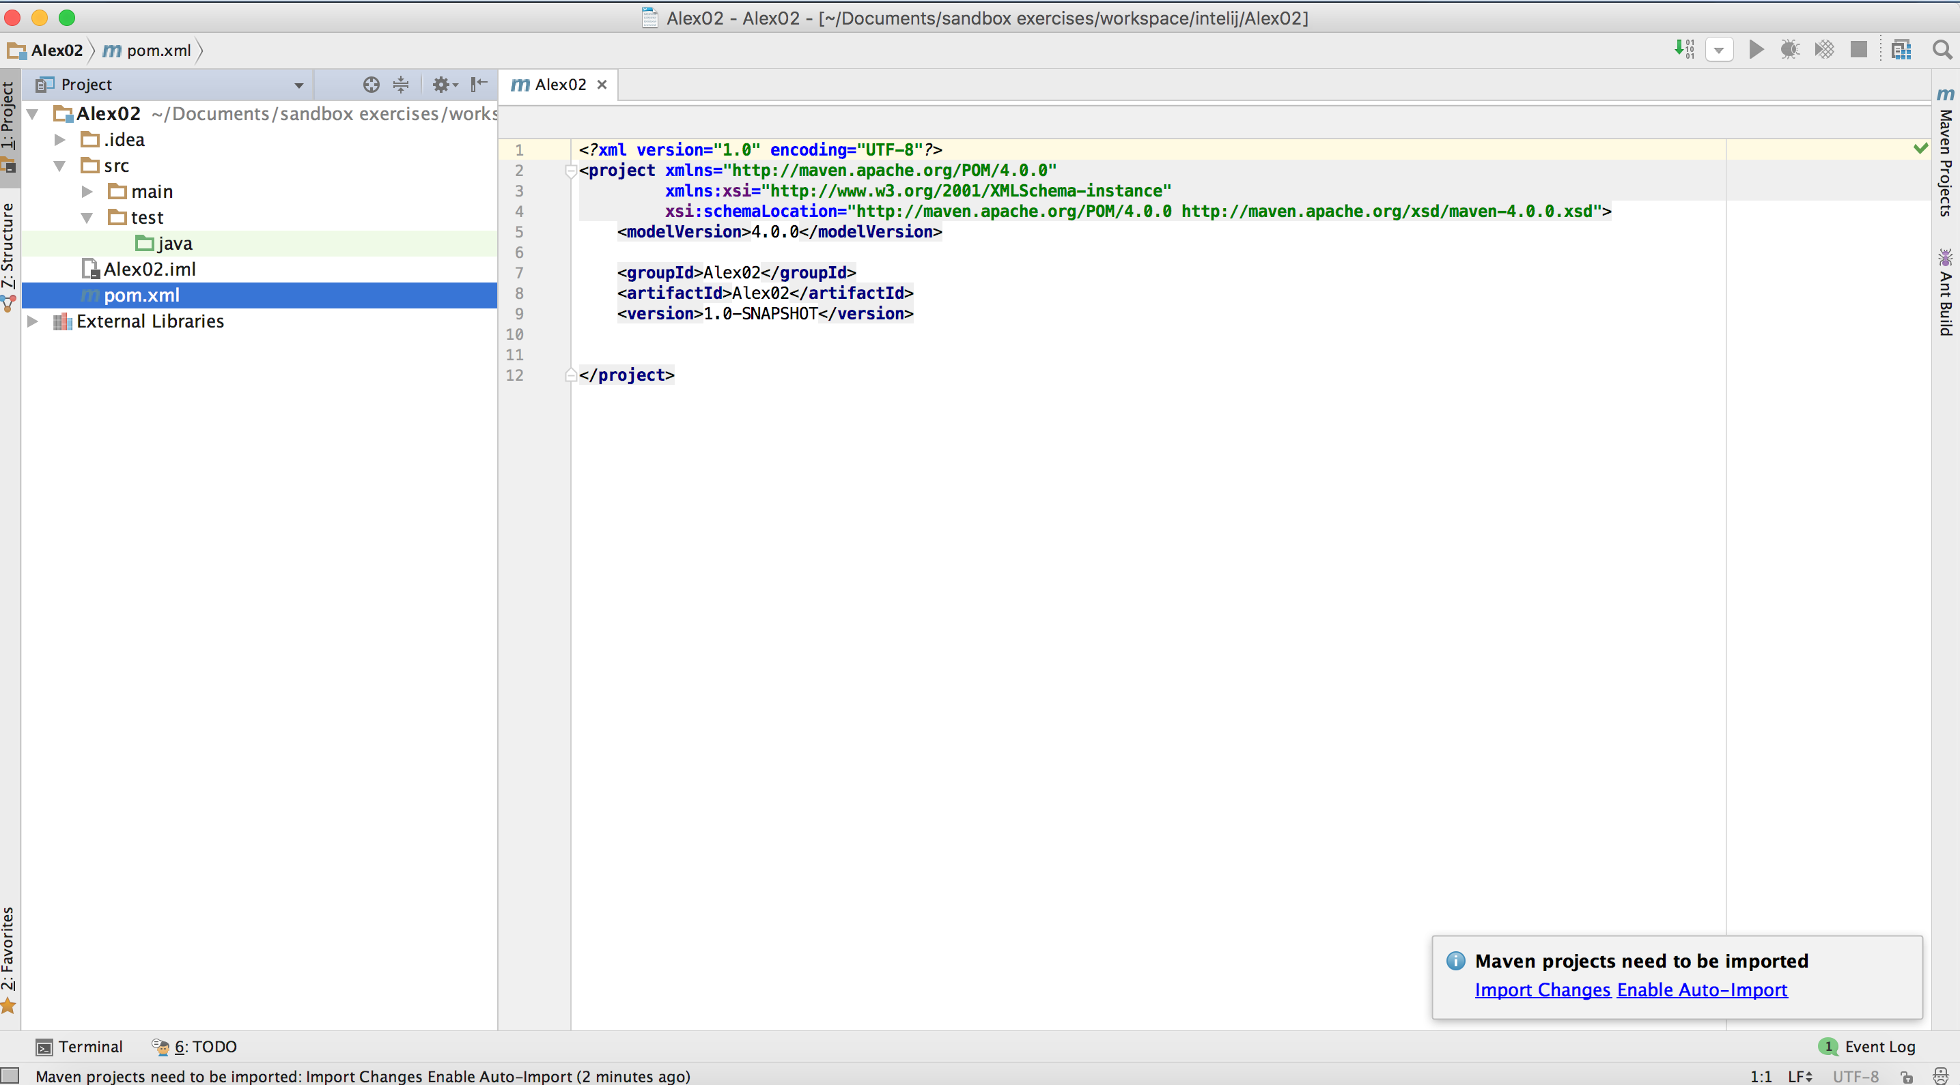

Alternatively, you can change the setting by IntelliJ->Preferences->Maven

->Importing. Here you can select the ”Import Maven projects automatically”.

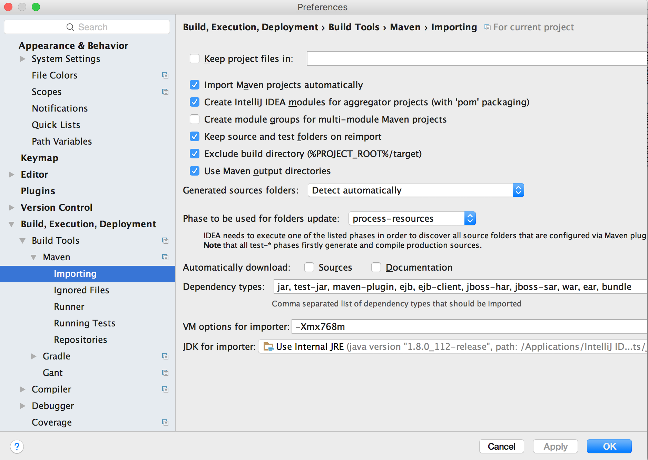

b)Change the POM-file by adding:  
<**dependencies**>  
 <**dependency**>  
 <**groupId**>org.seleniumhq.selenium</**groupId**>  
 <**artifactId**>selenium-java</**artifactId**>  
 <**version**>3.0.1(*1)</**version**>  
 </**dependency**>

<**dependency**>  
 <**groupId**>org.seleniumhq.selenium</**groupId**>  
 <**artifactId**>selenium-firefox-driver</**artifactId**>  
 <**version**>3.0.1(*1)</**version**>  
 </**dependency**>

<**dependency**>  
 <**groupId**>junit</**groupId**>  
 <**artifactId**>junit</**artifactId**>  
 <**version**>4.12(*2)</**version**>  
 </**dependency**>  
</**dependencies**>

For the elements placed in red I recommend strongly to have a look if there isn’t a newer version available. You can check this at:

-http://docs.seleniumhq.org/download/=>(*1)

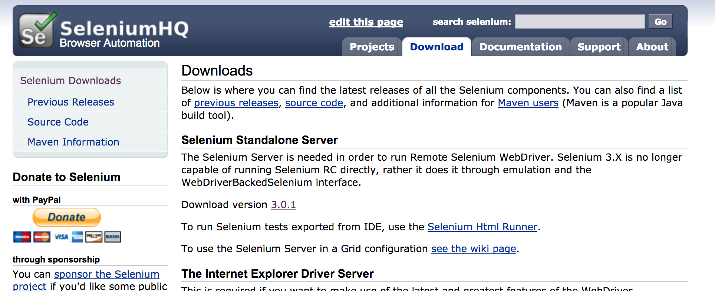

-https://mvnrepository.com/artifact/junit/junit/4.11=>(*2)

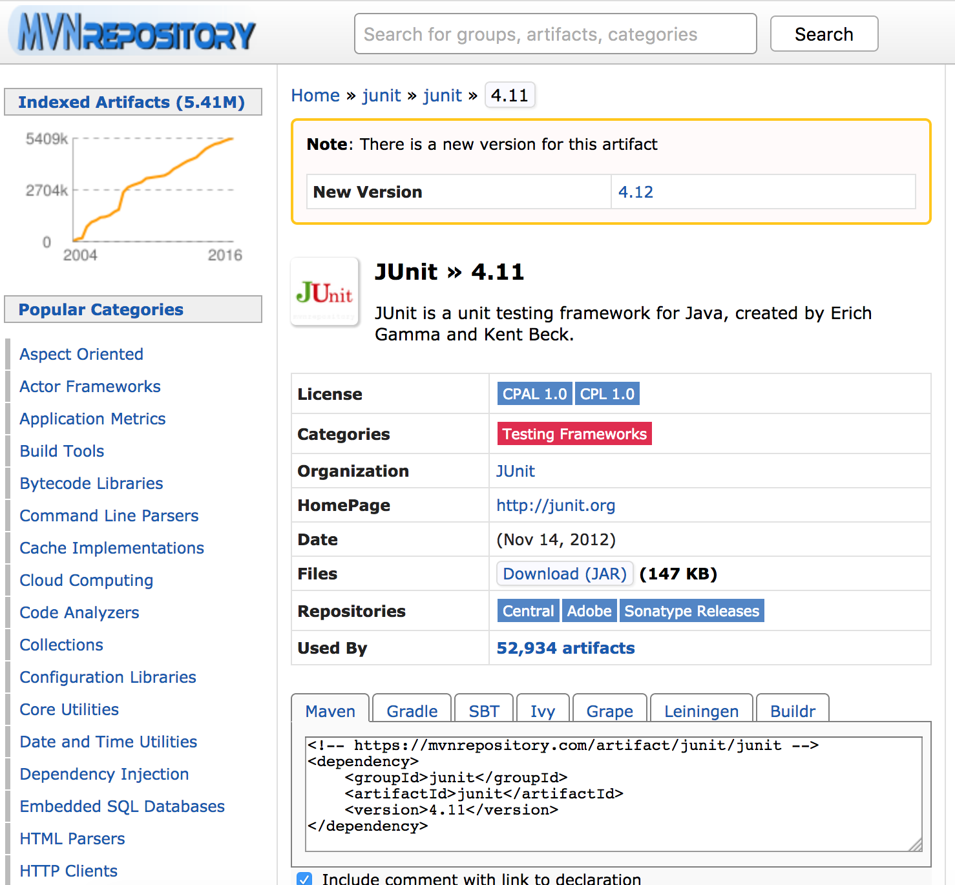

After this the file should look like:

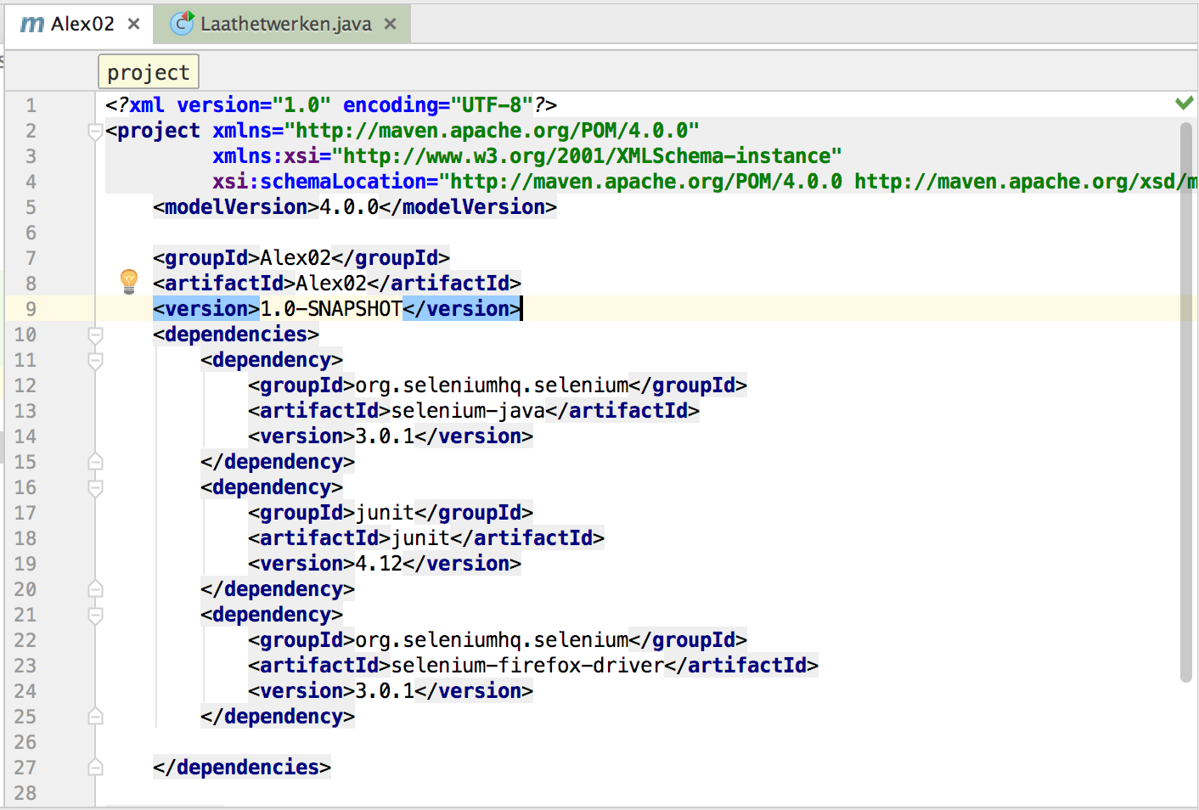

c)Go to “File” ->New->Directory

Give it the name “lib”

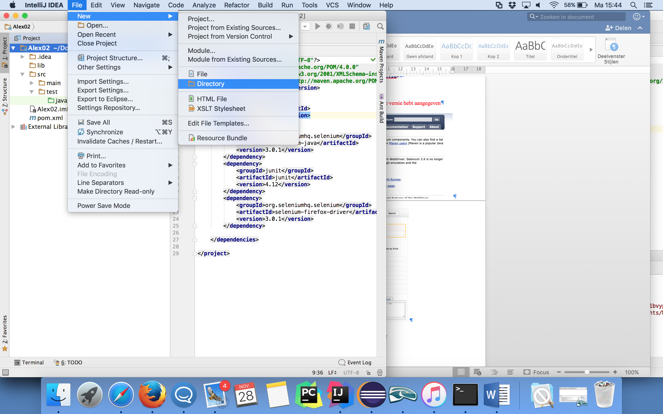

d)Go to the folder on your computer where the geckodriver is saved. Drag this file to the ‘lib’ folder in IntelliJ. Press “Ok” in the pop-up.

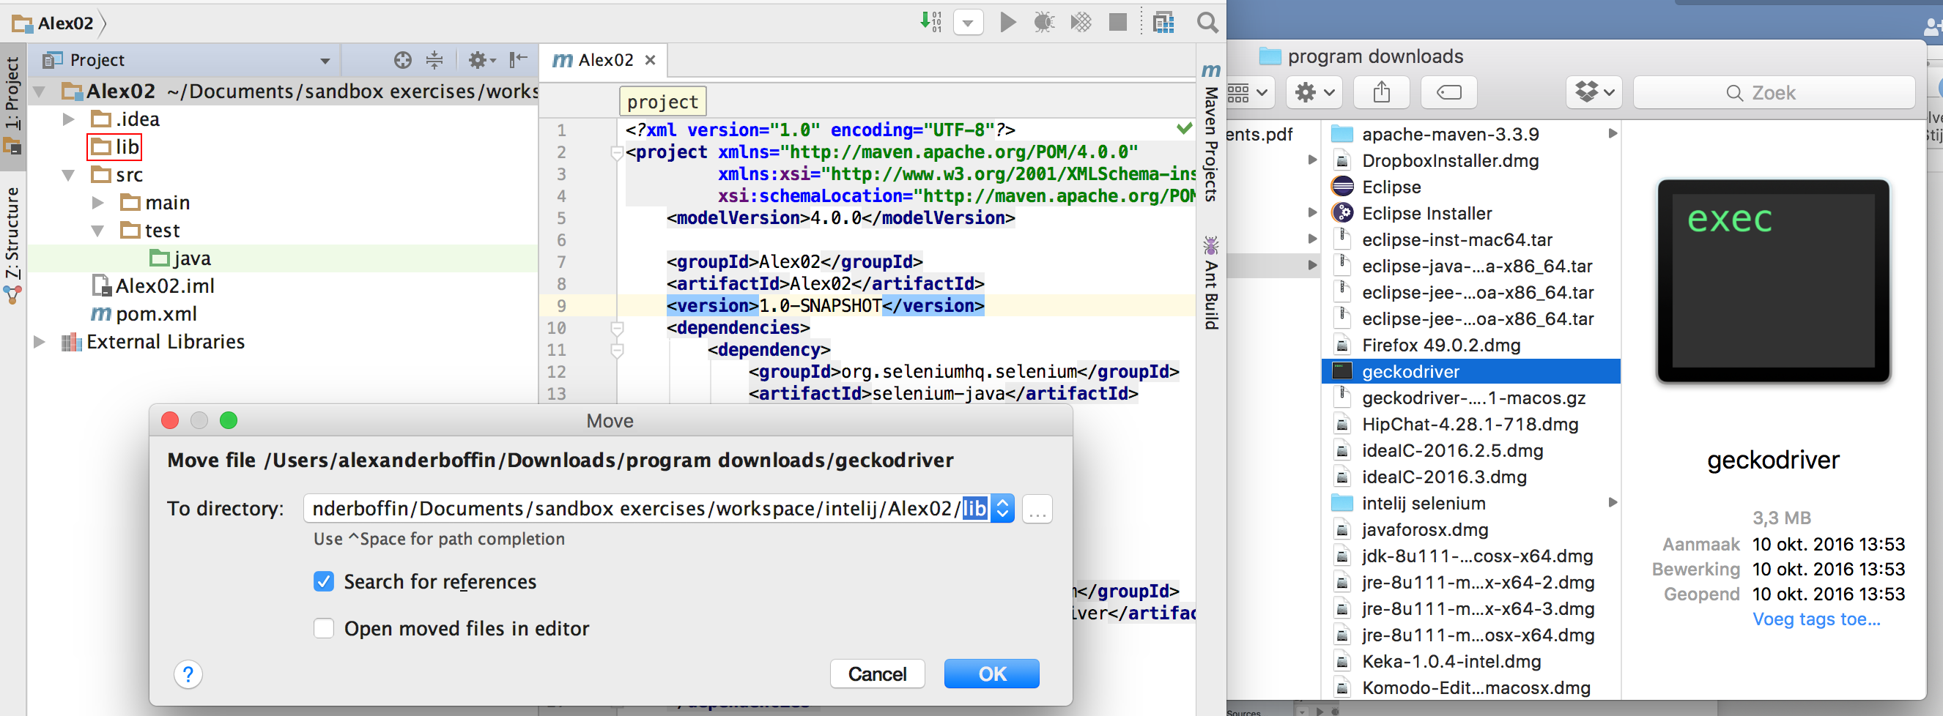

6)Make a Class + Write a test program (to see if everything works)

a)Go to src->test->Java in the left column. Left click and select new->java class. Chose a name for the class-file.

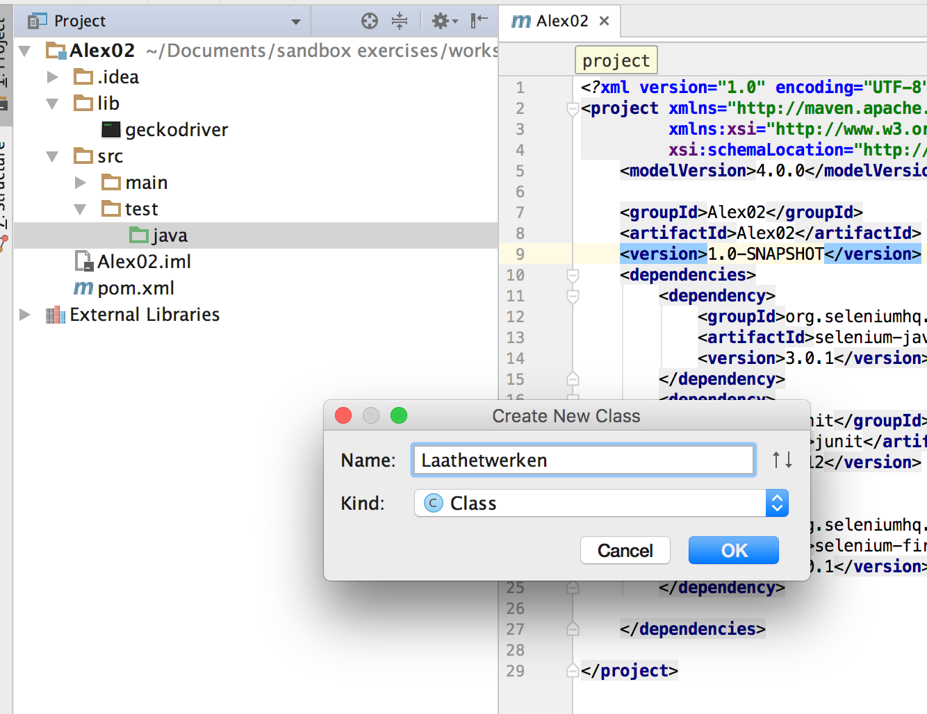

b)You can add the next text to the field:

@Test  
**public void** Alex01(){  
  
 System.*setProperty*(**"webdriver.gecko.driver"**, **"lib/geckodriver"**);  
 WebDriver driver = **new** FirefoxDriver();  
 driver.get(**"http://www.calmware.be"**);  
}

-

When the pop-up window appears click on “OK”. (This will import the necessary elements for running the program).

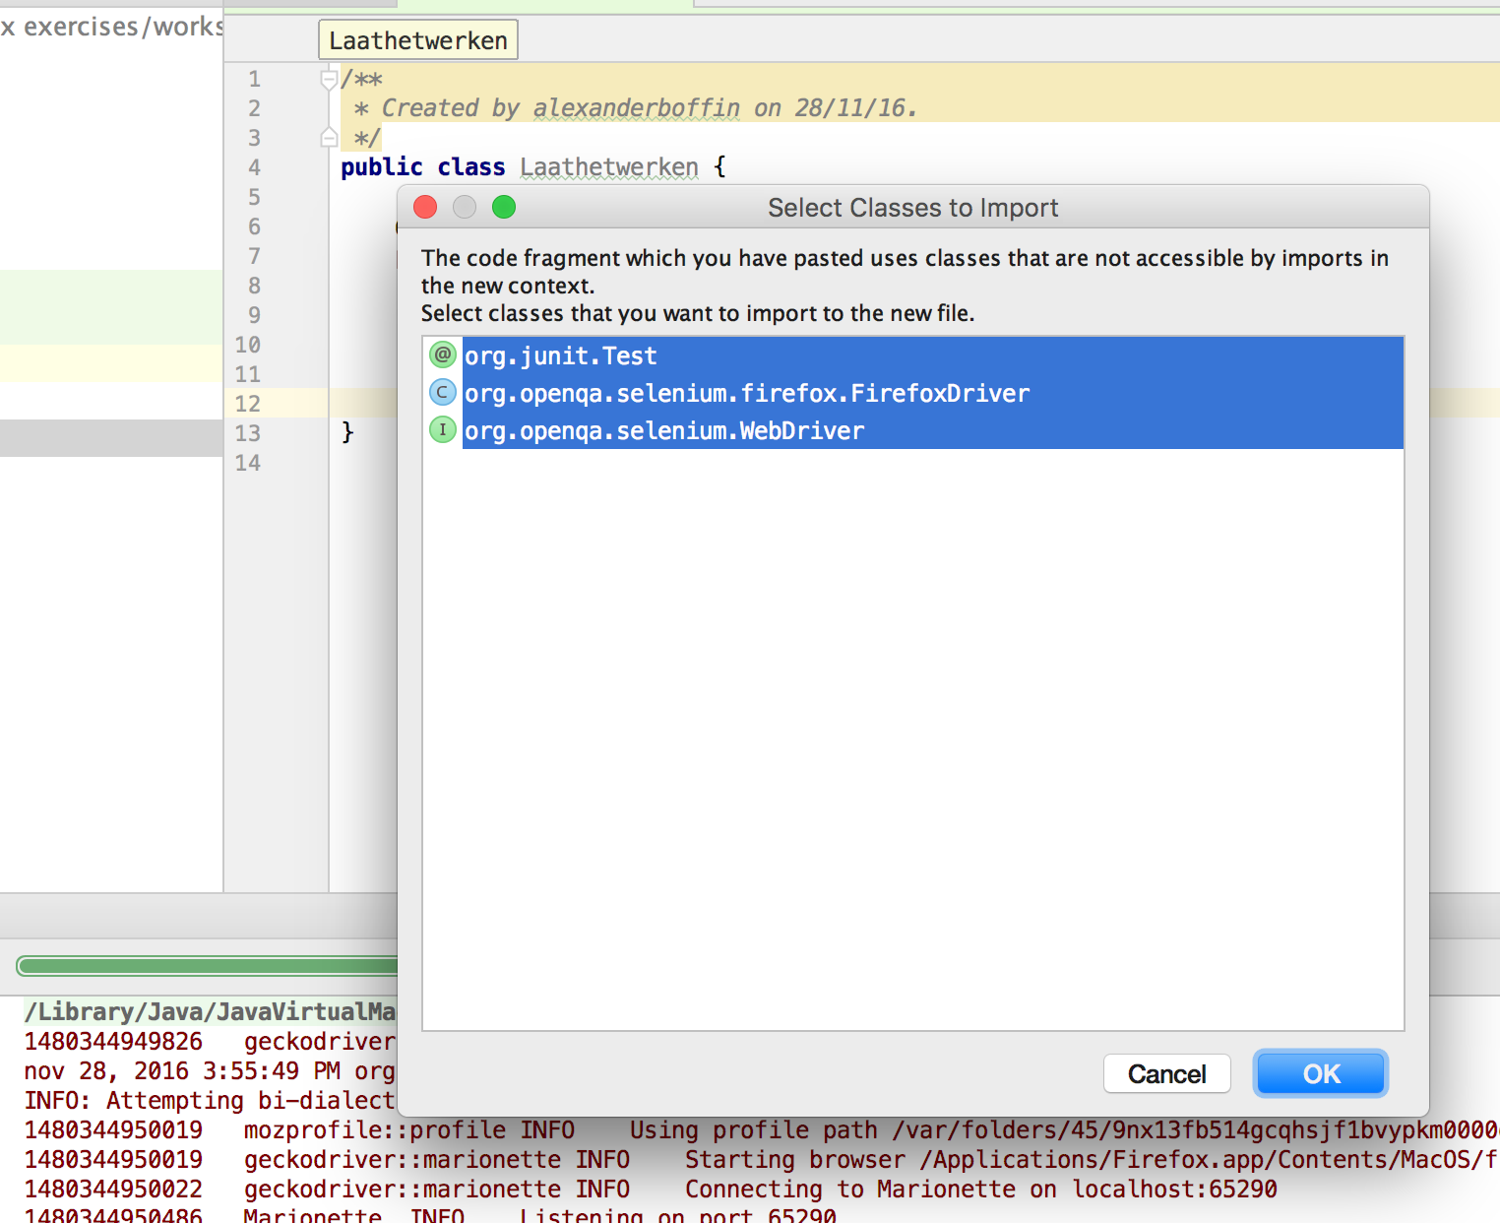

The file should look now like:

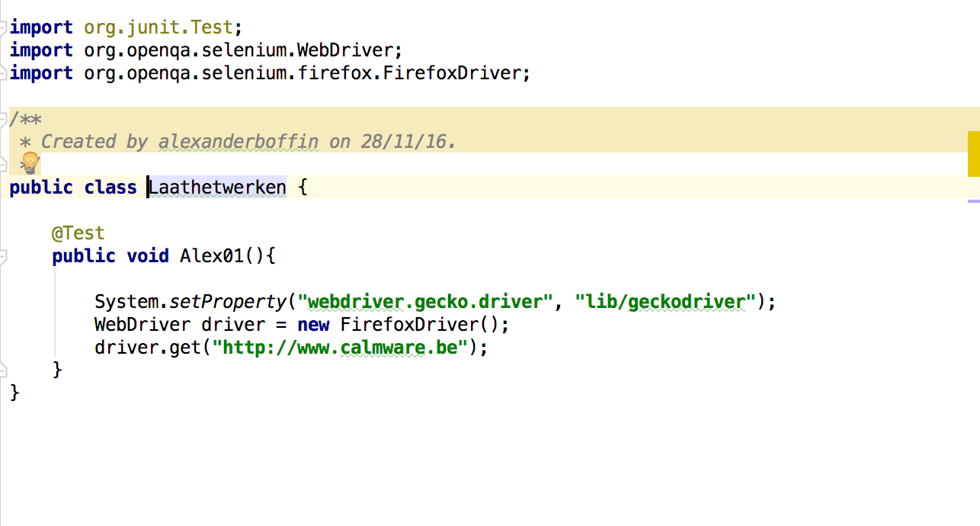

b) Go to the top menu and press RUN (green triangle top right or select the green orb at the height of the class and select then “Run”)

If everything is correctly installed, you should get this result:

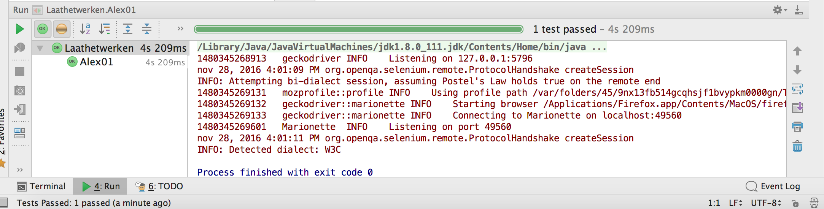

OPMERKING:

From Selenium 3 onwards the browsers have their own drivers. Because of this you need to make a path to this driver before you can open the browser in the test. For this you have to add:

System.setProperty(“webdriver.gecko.driver”, “PATH to geckodriver(*)”);

(*)=>Path to the driver (geckodriver)

* Can be in the form of the file system on the computer to the file. This takes the next form ”**/Users/naam user /Desktop/tussenliggende folders/geckodriver**”

=>When selecting the driver with finder in the computer directory (left click) you can select the “show information” and then copy the location. This can then be put at the “Path to geckodriver(*)”.

* In the set up the second approach is used. In IntelliJ you create a directory, drag and drop the file from the computer directory and then use this internal path. “System.*setProperty*(**"webdriver.gecko.driver"**, **"lib/geckodriver"**);”

If you didn’t do this, you’ll get the next error message:

Exception

java.lang.IllegalStateException: The path to the driver executable must be set by the webdriver.gecko.driver system property; at com.google.common.base.Preconditions.checkState(Preconditions.java:199) at org.openqa.selenium.remote.service.DriverService.findExecutable(DriverService.java:109) at org.openqa.selenium.firefox.GeckoDriverService.access$000(GeckoDriverService.java:37) at org.openqa.selenium.firefox.GeckoDriverService$Builder.findDefaultExecutable(GeckoDriverService.java:95) at org.openqa.selenium.remote.service.DriverService$Builder.build(DriverService.java:296) at org.openqa.selenium.firefox.FirefoxDriver.createCommandExecutor(FirefoxDriver.java:277) at org.openqa.selenium.firefox.FirefoxDriver.(FirefoxDriver.java:247) at org.openqa.selenium.firefox.FirefoxDriver.(FirefoxDriver.java:242) at org.openqa.selenium.firefox.FirefoxDriver.(FirefoxDriver.java:238) at org.openqa.selenium.firefox.FirefoxDriver.(FirefoxDriver.java:127)